EXPT NO: 9 | TRANSFORMER-BASED LLM CHATBOT USING STREAMLIT OR GRADIO
DATE: 3/11/26 | TRANSFORMER-BASED LLM CHATBOT USING STREAMLIT OR GRADIO

PRE-LAB QUESTIONS (PROVIDE BRIEF ANSWERS TO THE FOLLOWING QUESTIONS)

1.Explain the basic architecture of a Transformer-based LLM.
A Transformer-based LLM is a deep learning model used to understand and generate human language.

Main components:

- Input text
- Tokenization
- Embedding layer
- Positional encoding
- Self-attention mechanism
- Feed Forward Network
- Output layer

Flow: Input → Tokenization → Embedding → Self-Attention → Feed Forward → Output.

2. What is the role of tokenization in LLM response generation?

Tokenization converts input text into smaller units called tokens.
- Breaks text into words or subwords.
- Converts tokens into numerical IDs.
- Helps the model understand and process text.
- Supports response generation.

3. Explain how a pre-trained LLM generates responses to user queries.

- User enters a query.
- Text is converted into tokens.
- Tokens are converted into numerical vectors.
- Model understands the context using self-attention.
- Predicts the next token.
- Generates and displays the final response.

4. Differentiate between Streamlit and Gradio.

Streamlit | Gradio
Creates data dashboards. | Creates AI/ML demos.
Supports charts and graphs. | Supports text, images and audio.
Used for data analysis. | Used for model demonstrations.
Focuses on dashboards. | Focuses on model interaction.
Command: streamlit run app.py | Command: python app.py

5. State the purpose of temperature and maximum output length in text generation.

Temperature:
- Controls randomness and creativity.
- Low temperature gives predictable answers.
- High temperature gives creative answers.
Maximum Output Length:
- Controls the maximum number of tokens generated.
- Prevents very long responses.
- Helps control response size.

AIM

To develop an interactive chatbot using a pre-trained Transformer-based LLM and deploy it using Streamlit or Gradio.

SOFTWARE REQUIREMENTS
- Python
- TensorFlow / Keras / PyTorch
- Google Colab
- GitHub
- Hugging Face Transformers
- PyTorch
- Streamlit or Gradio

OBJECTIVES
Students will be able to:
- Understand the working of Transformer-based LLMs.
- Load and configure a pre-trained LLM.
- Generate responses using user prompts.
- Develop an interactive chatbot using Streamlit or Gradio.
- Test and deploy the application.

PROCEDURE

PART A: LOADING AND CONFIGURING A PRE-TRAINED LLM

Perform the following tasks:
- Select a suitable pre-trained LLM using Hugging Face Transformers.
- Load the model and its tokenizer.
- Prepare and tokenize sample user prompts.
- Generate responses by configuring suitable parameters, such as temperature and maximum output length.
- Display and examine the generated responses.

PART B: IMPLEMENTING CHATBOT FUNCTIONALITY

Perform the following tasks:
- Create a function to accept user queries and generate responses using the loaded LLM.
- Construct suitable prompts and display the generated responses.
- Maintain conversation history, if supported by the model.
- Test the chatbot with different queries and observe response quality.

PART C: DEVELOPING AN INTERACTIVE INTERFACE

Perform the following tasks:
- Select Streamlit or Gradio to develop the chatbot interface.
- Create a text input component and a submission mechanism.
- Connect the interface to the LLM response-generation function.
- Display responses in a chat-style layout.
- Run and test the application with different user inputs.

PART D: APPLICATION TESTING AND DEPLOYMENT

Perform the following tasks:
- Test the chatbot for response quality and usability.
- Observe limitations such as hallucinations and response latency.
- Organize the source code and create a requirements.txt file.
- Upload the project to GitHub.
- Deploy the application using a suitable platform, such as Hugging Face Spaces, if available.
- Document the results and limitations.
CODE
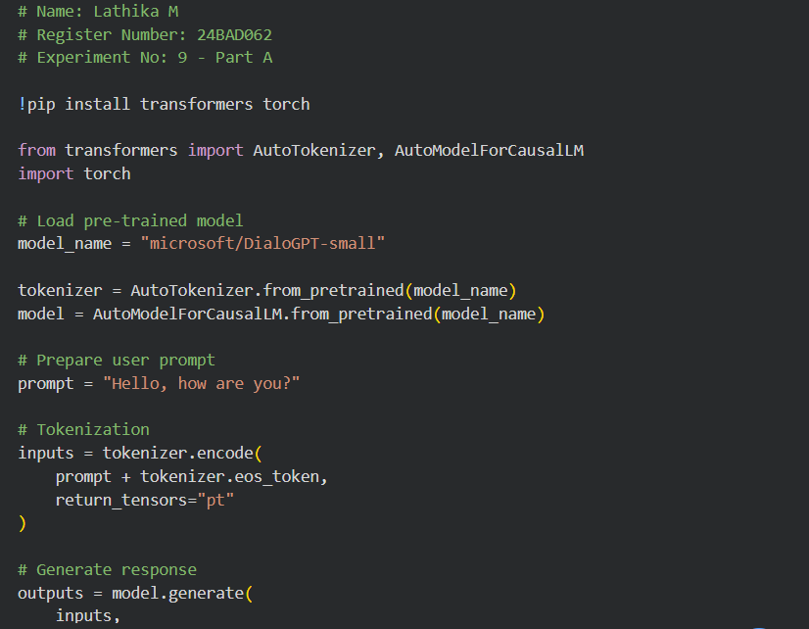
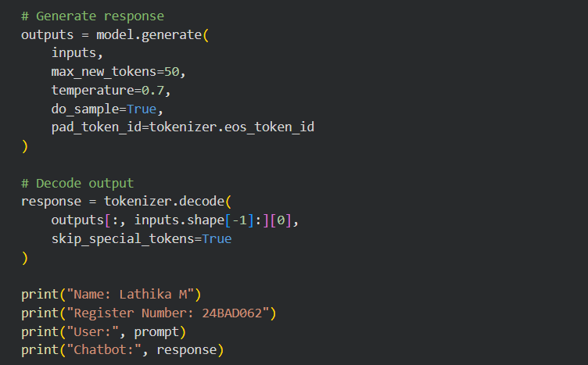

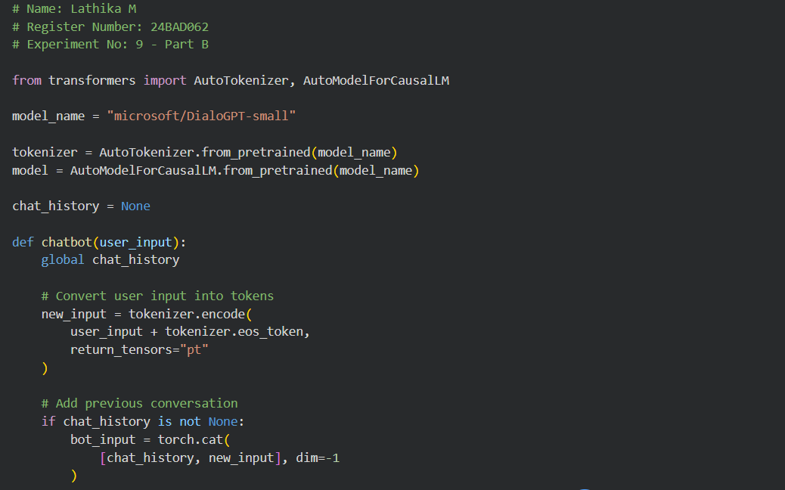

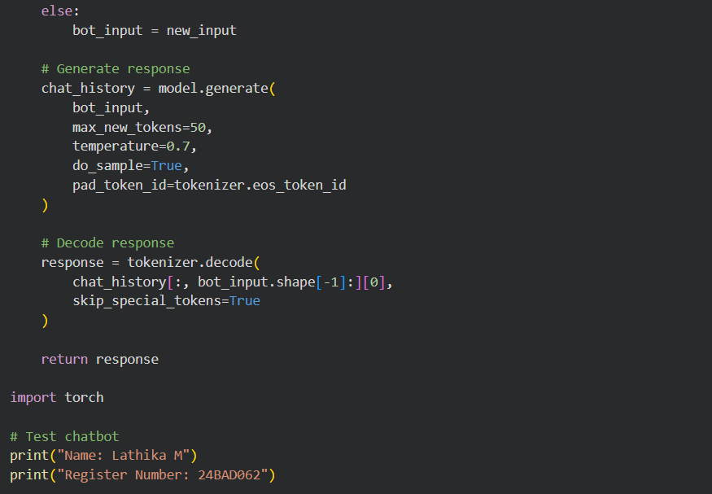
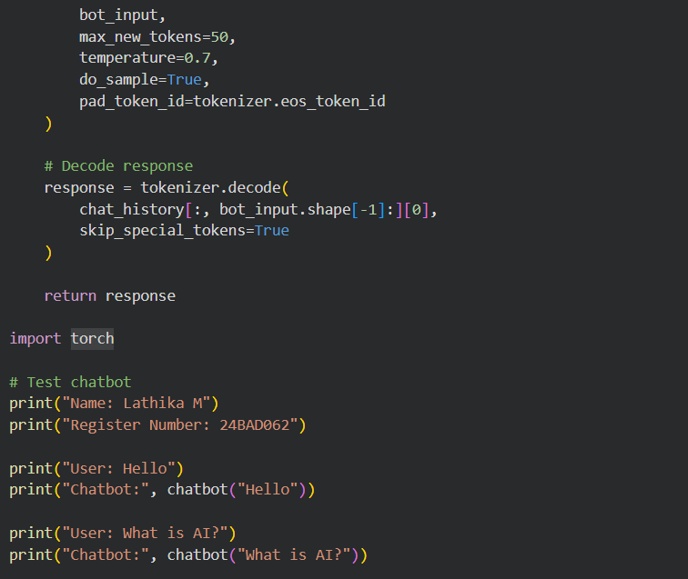
OUTPUT
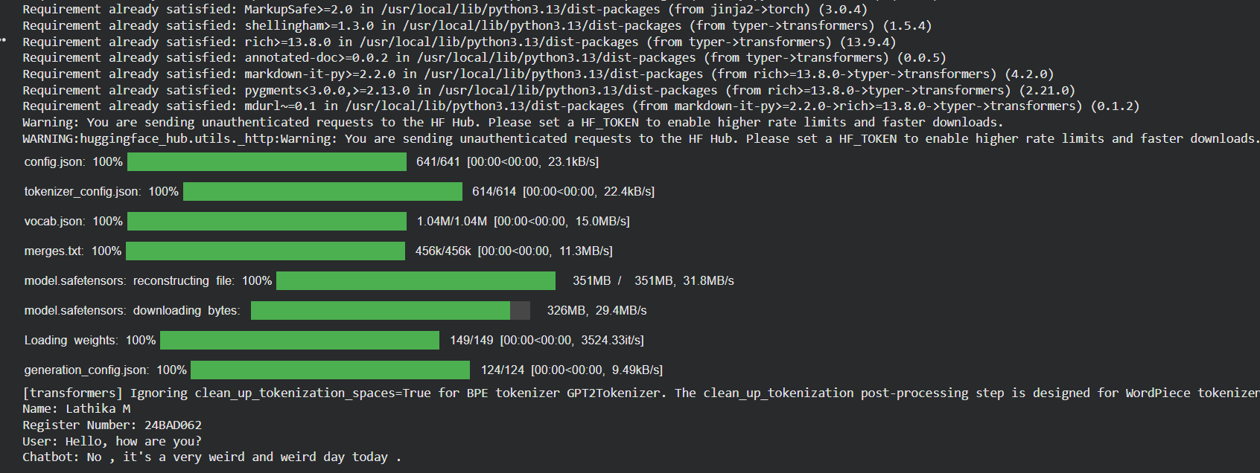
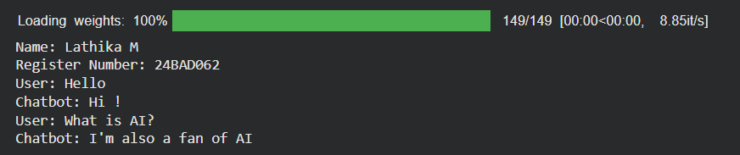
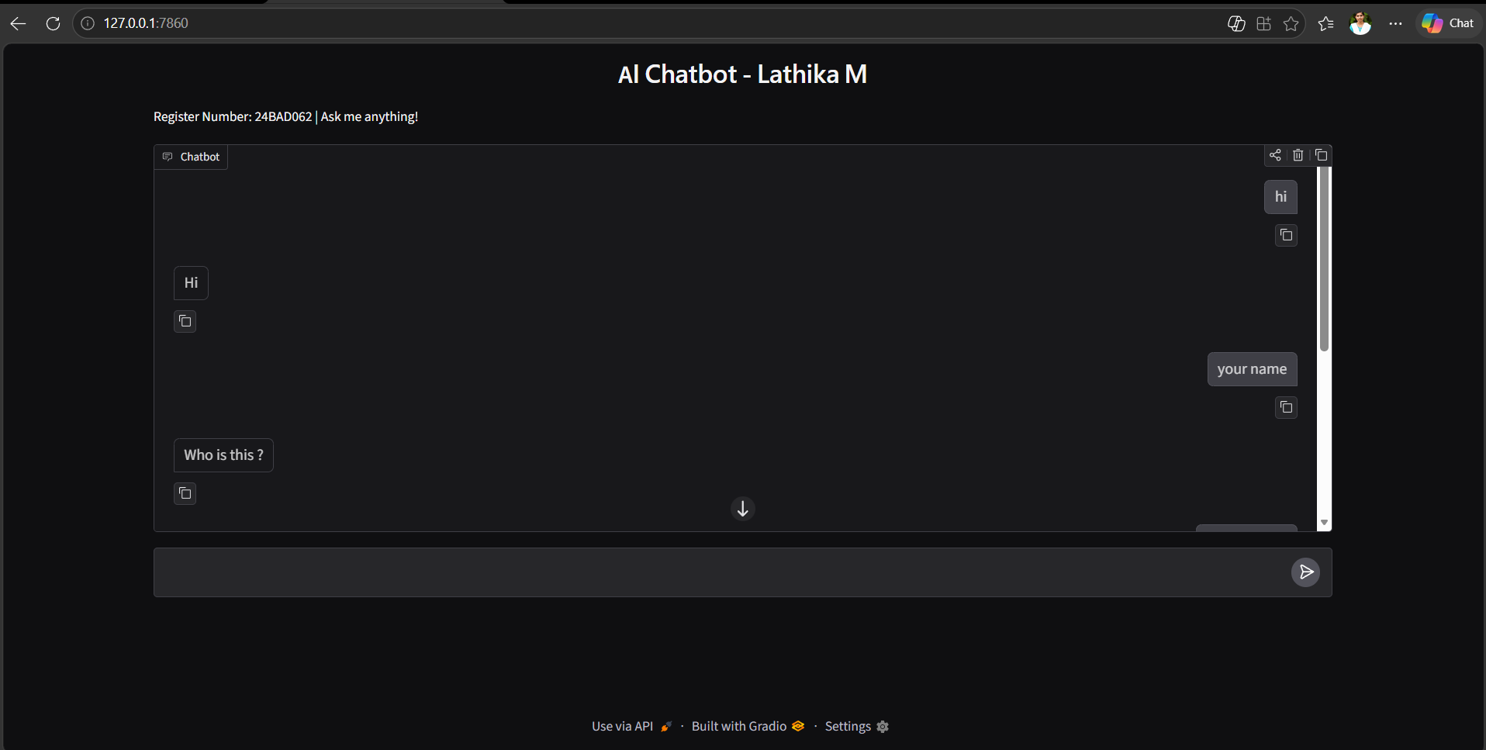

POST-LAB QUESTIONS (PROVIDE BRIEF ANSWERS TO THE FOLLOWING QUESTIONS)

1. Explain how an LLM generates responses from user prompts.
- User enters a prompt.
- Text is converted into tokens.
- Tokens are processed by the Transformer model.
- Model understands the context.
- Predicts the next suitable token.
- Generates and displays the response.

2. What is the importance of conversation history in a chatbot?
- Maintains previous conversation details.
- Understands the context of questions.
- Provides relevant answers.
- Supports continuous conversations.

3. Explain the effect of temperature on response generation.
Temperature controls the randomness of generated responses.
- Low temperature: Gives predictable and focused answers.
- High temperature: Gives creative and varied answers.
- Medium temperature: Gives balanced answers.

4. Differentiate between local execution and cloud deployment.

Local Execution | Cloud Deployment
Runs on a personal computer. | Runs on cloud servers.
Uses local system resources. | Uses cloud resources.
Internet may not be required. | Usually requires internet.
Limited by computer capacity. | Can scale resources easily.
Mainly accessed locally. | Can be accessed from anywhere.

5. State two limitations of LLM-based chatbots.

- Incorrect Answers: LLMs may generate false or misleading information.
- Lack of Real Understanding: They may fail to understand complex context and emotions.

ASSESSMENT
Description | Max Marks | Marks Awarded
Pre Lab Exercise | 5
In Lab Exercise | 10
Post Lab Exercise | 5
Viva | 10
Total | 30
Faculty Signature

